THE CORPORATION OF THE TOWNSHIP OF NORTH STORMONT
NOTICE OF PUBLIC HEARING REGARDING
AN APPLICATION FOR MINOR VARIANCE
FILE NO. A-2024-09 (Burgi)

OWNER/APPLICANT: LOCATION OF PROPERTY:
Regula Burgi Roll: 041101600865000
Part of Lots 13 and 14, Concession 6
Geographic Township of Roxborough, Township of North Stormont
17234 McNeil Road, Maxville, ON, K0C 1T0
(keymap attached)

TAKE NOTICE THAT an application under the above file number will be heard by the Committee of Adjustment on the 6th day of May 2024 at 8:30 A.M. at the Township of North Stormont Municipal Office, 15 Union St., Berwick, ON, under the authority of Section 45 of the Planning Act.

THE PURPOSE OF THE APPLICATION is to permit relief from Section 11.2 of Zoning By-law No. 08-2014, which requires all secondary dwellings in an agricultural zone to be 75 m². The proposed floor area would be 47 m².

THE EFFECT OF THE APPLICATION

- Reduce the minimum floor area for a secondary dwelling unit from 75 m² to 47m².

The proposed reductions will allow for a secondary dwelling - detached on the subject lands.

ADDITIONAL INFORMATION relating to the application is available for inspection during normal office hours at the Township of North Stormont Office, located at 15 Union St. Berwick, ON.

IF A PROPERTY CONTAINS SEVEN OR MORE RESIDENTIAL UNITS, the owner is required to post this notice at a location that is visible to all of the residents. O. Reg. 175/16, s. 1 (8-10)

PUBLIC HEARING
You are entitled to attend this public hearing in-person, or you may be represented by counsel or an agent to give evidence about this application. Signed, written submissions that relate to an application shall be accepted by the secretary-treasurer before or during the hearing of the application at the address above and shall be available to any interested person for inspection at the hearing. Statutory Powers Procedure Act, R.S.O. 1990.

FAILURE TO ATTEND HEARING
If you do not attend this public hearing, it may proceed in your absence and, except as otherwise provided in the Planning Act, you will not be entitled to any further notice in the proceedings. Statutory Powers Procedure Act, R.S.O. 1990, c.S.22, s 7.

NOTICE OF DECISION
A certified copy of the decision, together with a notice of the last day for appealing to the Ontario Land Tribunal shall be sent, not later than 10 days from the making of the decision to the applicant, and to each person who appeared in person or by counsel at the hearing and who filed with the secretary-treasurer a written request for notice of the decision. Planning Act, R.S.O. 1990, c.P.13, s. 45 (10)

DATED this 26th day of April 2024 at the Township of North Stormont.

Township of North Stormont Committee of Adjustment
Anmol Burmy, Junior Planner & Secretary-Treasurer
15 Union St., PO Box 99
Berwick, ON K0C 1G0
Phone: (613) 984-2821
Fax: (613) 984-2908
planning@northstormont.ca

Keymap

Minor Variance Application No. A-2024-09 (Burgi)

Roll No.: 041101600865000

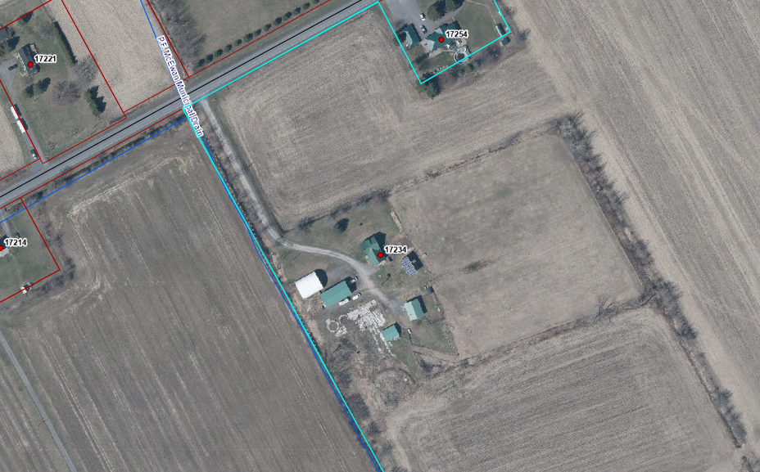
Subject Lands

