October 24th, 2019
RE: Temporary Road Closure – Concession 10-11 Road, Crysler
Concession 10-11 Road will be closed to accommodate the Nation Rise Wind Farm construction activities. The road will be closed from County Rd 32 to Reveler Road.
The closure is effective as of 9 a.m. on Friday, October 25th, 2019 and will remain closed until the road closure signs have been removed or until further notice is provided.
Residents will have access to their properties and are encouraged to plan alternative routes as necessary. Please see map below for full details on the closure. The yellow area on the map is the closed portion of the road.
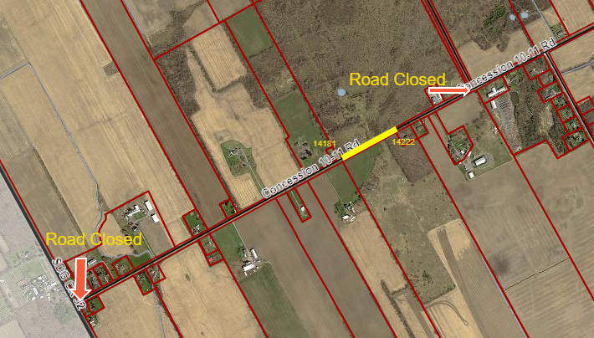
Please visit www.northstormont.ca for the most up-to-date information.
Contact the Public Works Department should you have any questions regarding the road closure at 613-984-2821 ext 227 or by e-mailing bhenderson@northstormont.ca

